PRACTICAL NO 1
AIM:-Working with DDL and DML commands
- DDL commands
Q1) create database
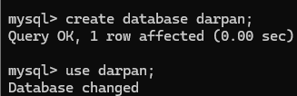
Q2) create table
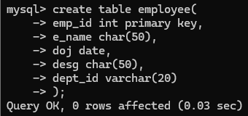
Q3) describe table
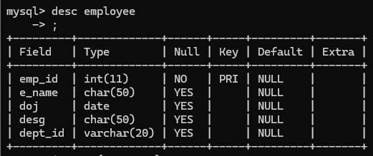

- DML commands
Q) Insert query
- Single insert query
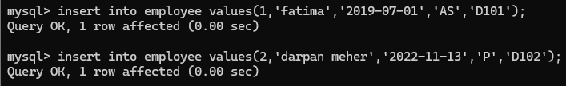
- Multiple data insertion
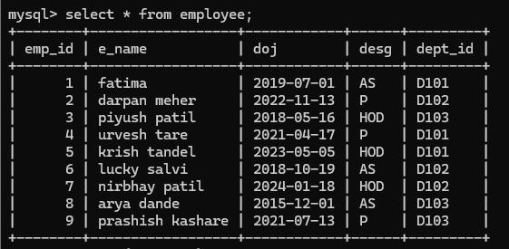
Q1) display name for emp id =3
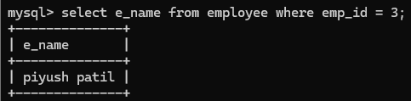
Q2) Display name ,designation and department id of all HOD
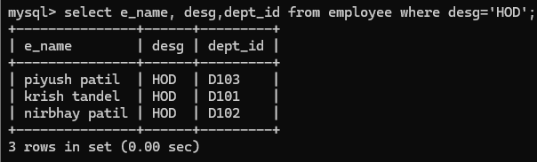
Q3) update command
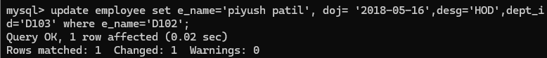
Q4) Delete the data
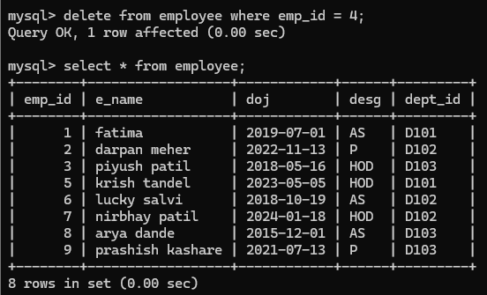

- SQL for Data Analysis
Add new column salary and add data
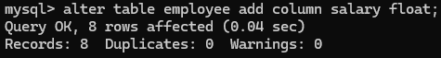
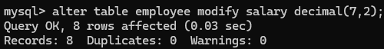
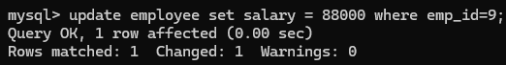
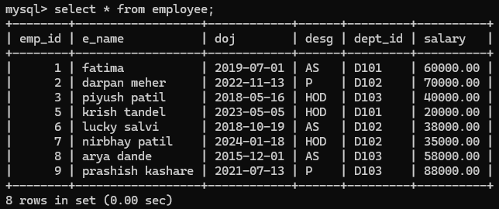

- Display all the employee info who have joined after 1st of july, 2020
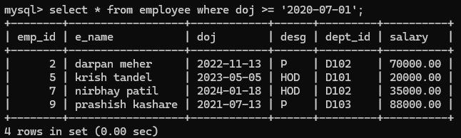
- Display the name ,id of employee who has id more than 4 or more
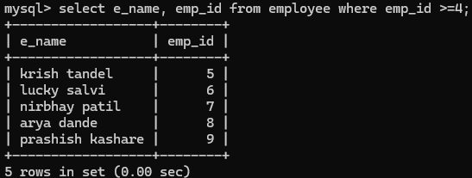

- Display the name and bonus_salary which is 5% of existing salary of all employee
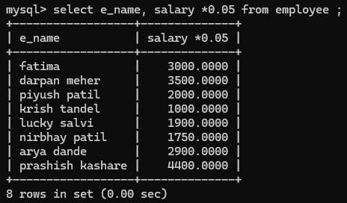
- Display the name and the salary with addition of bonus salary of 5% for all employee
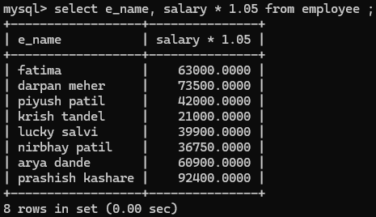
- Display all the info of employee who’s date of join is 01-07-2020 and desg is HOD
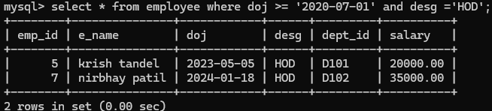

- Display all info of employee having salary more than equal to 30,000 and less than equal to 50,000
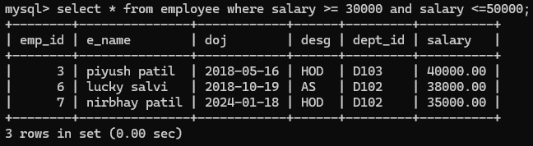
- Select all info of employee having salary 20,000, 40,000 or 58,000
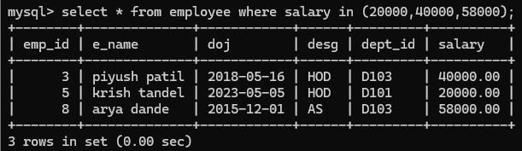

Q) NEW DATA TABLE
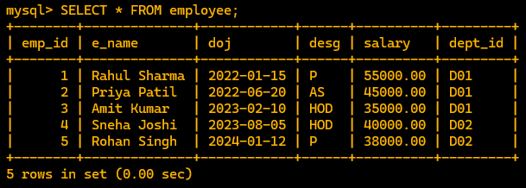

- Using like operators in the query where ‘_’ key word is used for the char and ‘%’ is used for the string

  - Where the info will be printing of all employee where ‘a’ char contains at the specific 5 position in the name
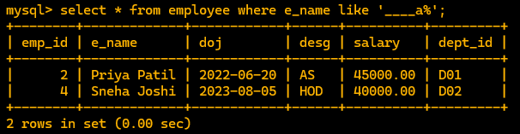
  - Where the name containing letter h in their name will be displayed
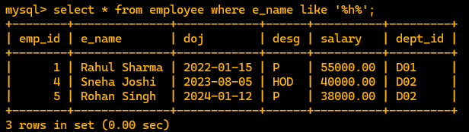
  - Display the info of employee where their name contains exact two ‘a’ letter in their name
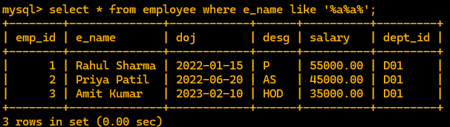
  - Display the info of all employee where first name is only of 4 letters respective of surname
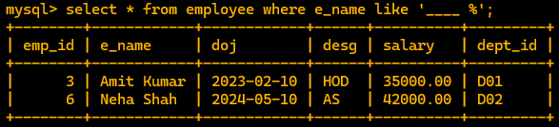

- NULL and NOT NULL OPERATORS
- Insert new data with null values
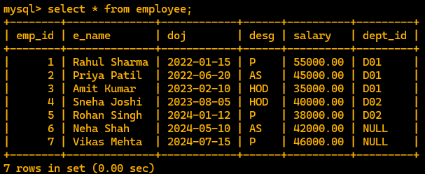
  - NULL Query
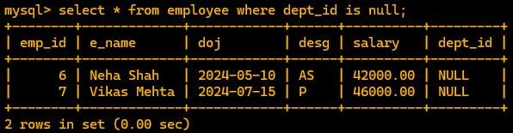
  - NOT NULL Query
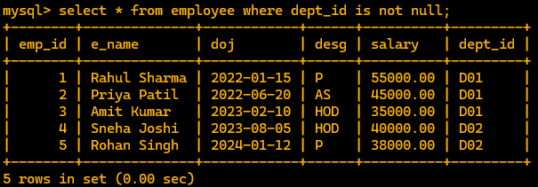

  - Treating the null values


